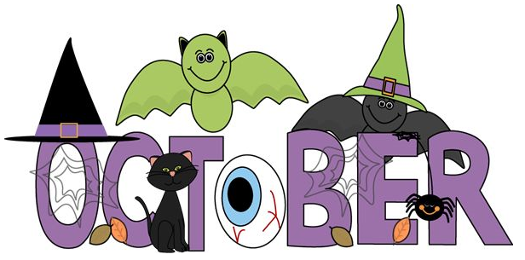
What are nursery up to in…

October Curriculum Information
Our topic this month is “Down on the Farm.” We will be exploring the season of Autumn and the changes it brings. We will also be learning about Autumn on the farm and Harvest time. I am sure the boys and girls will be able to share their own experiences of Autumn and helping Grandads, Daddies and Uncles bringing in the crops. If you have any photos of your child helping around the farm we would love to see them.
We will be making an Autumn display and would love if you could send in a piece of fruit or a vegetable for it. Please have a look for different autumn fruits- chestnuts, acorns, rosehips etc. and bring them into nursery for our investigation table. We would also love a variety of autumn leaves, preferably dry and of different sizes and shapes, for discussion and for art activities.
Our stories and rhymes where possible will be based around this theme for the month.
We will also explore some well know Fairy Tales this month such as ‘Goldilocks and the 3 Bears’ and ‘The Three Little Pigs.”

We will be having a Hallowe’en Dress Up Party in Nursery school on Friday 28th October. We encourage the children to participate but no masks or face paints please.
Halloween break is Monday 31st October to Friday 4th November inclusive.

We will also be scooping out pumpkins, making chocolate apples and playing Hallowe’en games with nothing scarier than spiders.

We will be exploring autumn colours – red, yellow, orange and brown and we will be looking at the different leaf shapes and comparing sizes of our autumn finds- big/small/biggest/smallest.

Home Tasks
Continue working with your child at home to develop their self-help skills and promote independence. Encourage them to dress and undress, taking off their own jumpers and putting them back on again. Demonstrate what to do if the arm of their jumper is inside out. Support your child with independence at the toilet. Demonstrate and explain the need to wash our hands after using the toilet and before we eat a meal.

